Lab Manual
Lab # 1
Task: How to access Course management System from UET website
Step 1:
Open the web browser.

Step 2:
Enter the web site address in URL(universal resource locator)

Step 3:
Web site Address
www.uettaxila.edu.pk
Display page against the entered website address.
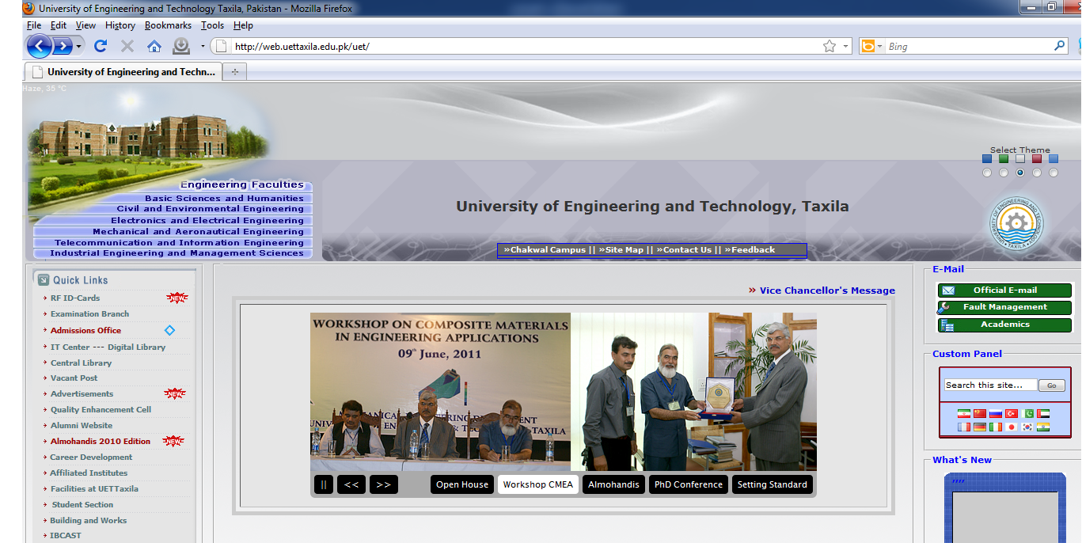
Step 4:
Select the link named “Telecommunication and Information Engineering” from Top Left display Menu.
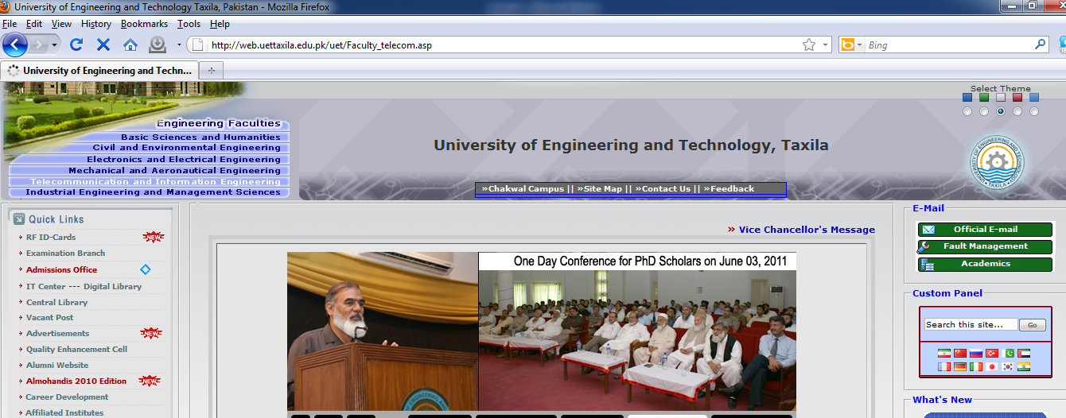
Step 5:
Display page against the link “Telecommunication and Information Engineering” . Select the link “Department of Software Engineering” from display departments.
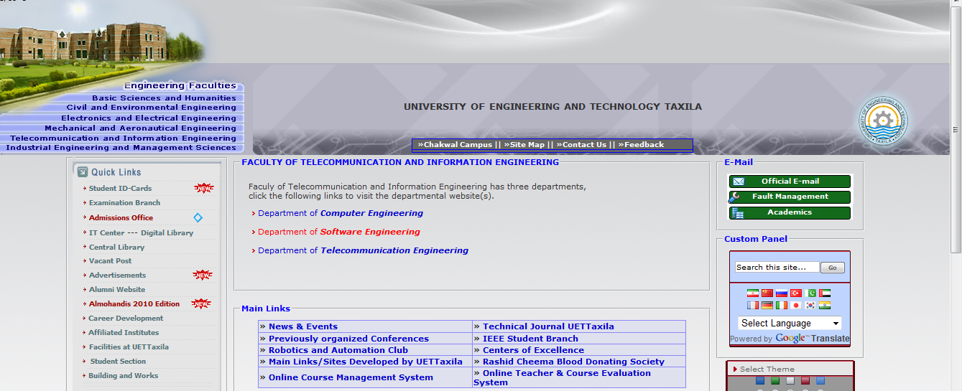
Following is the display page against the Link “Department of Software Engineering”:

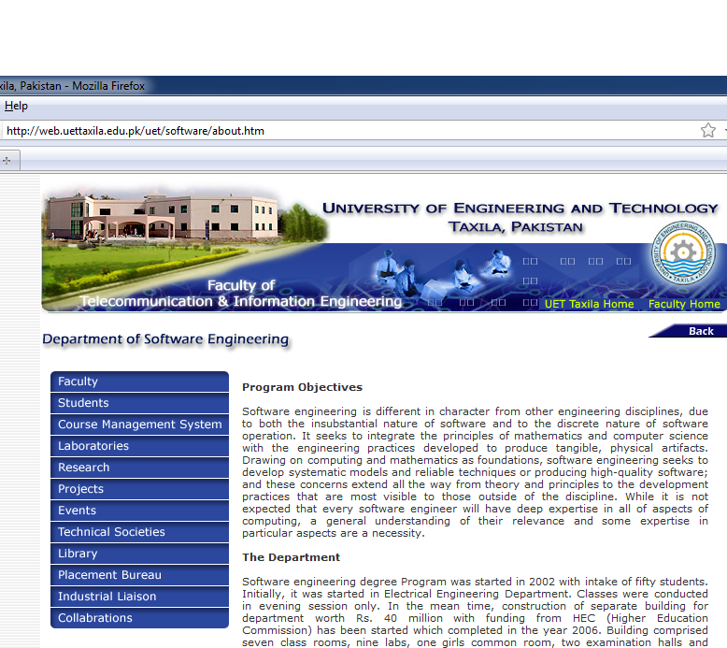
Step 6:
Select the “Course management System” from the Left display menu options.

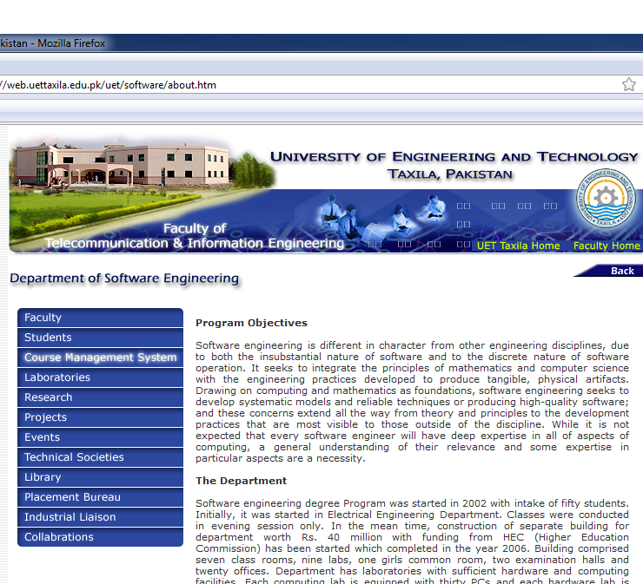
Step 7:
After clicked on link “Course management System” following information related to the current semesters will display:
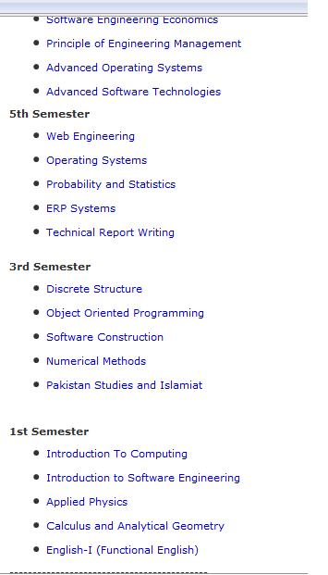
Choose the subject against 1st semester Heading.

Step 8:
If you click on link “Introduction to computing” following information will display to you.

